Order Moving
This is process to move desired orders from one atelier to another atelier.
Order moving is possible for Suits & Knit order.
In Suits, there are two ateliers: Suits China & Suits India.
In Knit, there are two ateliers: Knit A & Knit B.
Criteria:
The order moving is possible under few criteria’s:
- The order can be moved within the atelier until Status: Processed. The orders from Status: To atelier cannot be moved.
- The RM orders with Status: Pre-Readymade order, cannot be moved within ateliers
Requirements:
- During moving orders, the Fabric, Lining, Buttons, TryOns sizes, Trimmings, Fabric Supplier label and DOVs, stock should be available.
- All materials should have CAD as Yes i.e. No extra days

Method to move order:
- Select order (eg: Suits India) from Admin order overview
- From Action Type option choose: Move orders to suit.
- Check all the availability of the materials.
- Move orders to Atelier.
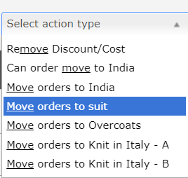

Exceptions:
- For Knit B atelier, only Knit types, Extra fine merino wool and Cotton & Silk are applicable. Other Knit types are invalid.
- If the Order moving, for any material as mentioned above, is unavailable and there is a red signal, the orders would not be moved.
- System does not check stock /availability of shop label and fabric supplier label while order moving
- System does not recalculate design option values /labels or any order info after order moving to desired atelier except Shipment and delivery date of order.

